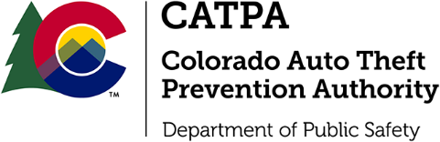

FY2025 CATPA Intent to Apply Announcement

Consistent with §42-5-112 C.R.S, the CATPA Office is seeking Intent To Apply Letters for funding opportunities which may become available in the near future for Colorado vehicle theft prevention, enforcement, prosecution or offender rehabilitation, victim support of auto theft, technology enhancement and other programs that involve automobile theft or automobile theft-related crimes.
Intent To Apply Letter Template:
- Name of agency with contact information including both a telephone number and email
- Brief description of the project including the need the project will serve
- Brief budget description
Letters can be emailed to Kenya.lyons@state.co.us with the subject line FY25 CATPA_D1

If you have any questions, contact Kenya Lyons at 303-253-0694

